Router Configuration and Routing Protocols using Cisco Packet Tracer

Computer Networks Practical Assignment

Submitted By
Student Name: MAND Fernando
Student ID: 39271
Module Name: Computer Networks
Assignment Title: Router Configuration and Routing Protocols using Cisco Packet Tracer
Submission Date: 15 June 2026

Introduction
This assignment demonstrates the configuration of Cisco routers using Cisco Packet Tracer. The practical activities include basic router configuration, implementation of static routing, and dynamic routing using RIP and EIGRP protocols. The objective is to establish successful communication among multiple networks and verify connectivity through routing tables and ping tests.

Task 1 – Basic Router Configuration

Objective
Configure the router hostname, secure console access with a password, and enable login authentication.

Configuration Commands
enable
configure terminal
hostname KandyNSBM_39271
line console 0
password NSBM
login
end
write memory

Explanation of Commands
Command | Purpose
hostname KandyNSBM_39271 | Changes the router hostname
line console 0 | Accesses console configuration mode
password NSBM | Sets the console password
login | Enables password authentication
write memory | Saves configuration permanently

Hostname configuration and Console password configuration
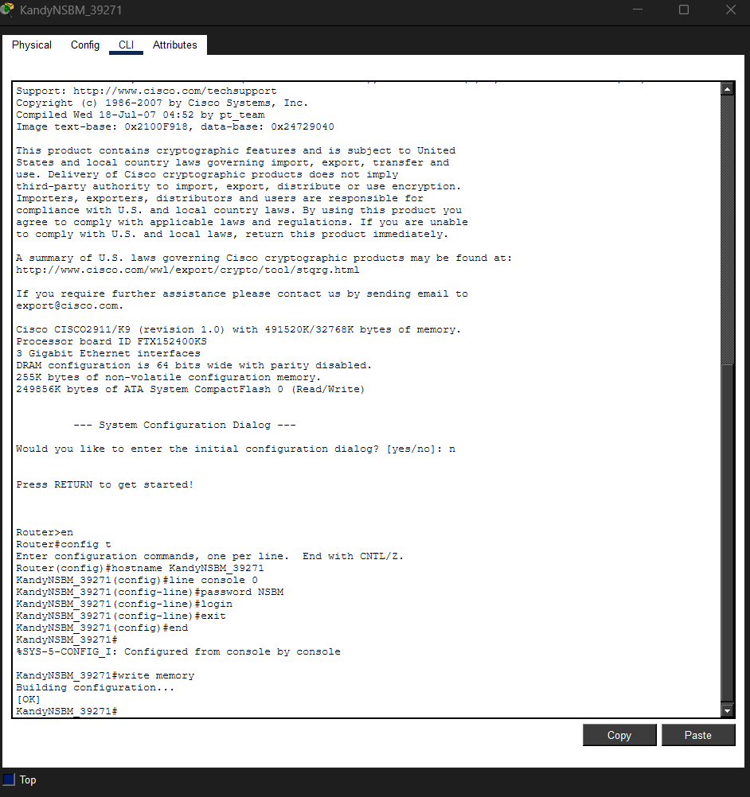

Result
The router hostname was successfully changed to KandyNSBM_39271 and console access was secured using the password NSBM.

Task 2 – Static Routing Configuration

Network Topology
The network consists of three routers:
- ComputingRouter
- BusinessRouter
- ScienceRouter

Network Addressing
Device | Interface | IP Address
ComputingRouter | G0/2 | 192.168.1.1
ComputingRouter | G0/1 | 12.0.0.1
ComputingRouter | G0/0 | 11.0.0.1
BusinessRouter | G0/2 | 192.168.2.1
BusinessRouter | G0/1 | 12.0.0.2
BusinessRouter | G0/0 | 10.0.0.1
ScienceRouter | G0/1 | 192.168.3.1
ScienceRouter | G0/0 | 10.0.0.2
ScienceRouter | G0/2 | 11.0.0.2

Router Configurations

ComputingRouter
interface g0/2
ip address 192.168.1.1 255.255.255.0
no shutdown
interface g0/1
ip address 12.0.0.1 255.255.255.252
no shutdown
interface g0/0
ip address 11.0.0.1 255.255.255.252
no shutdown
ip route 192.168.2.0 255.255.255.0 12.0.0.2
ip route 192.168.3.0 255.255.255.0 11.0.0.2

BusinessRouter
interface g0/2
ip address 192.168.2.1 255.255.255.0
no shutdown
interface g0/0
ip address 10.0.0.1 255.255.255.252
no shutdown
interface g0/1
ip address 12.0.0.2 255.255.255.252
no shutdown
ip route 192.168.1.0 255.255.255.0 12.0.0.1
ip route 192.168.3.0 255.255.255.0 10.0.0.2

ScienceRouter
interface g0/1
ip address 192.168.3.1 255.255.255.0
no shutdown
interface g0/0
ip address 10.0.0.2 255.255.255.252
no shutdown
interface g0/2
ip address 11.0.0.2 255.255.255.252
no shutdown
ip route 192.168.1.0 255.255.255.0 11.0.0.1
ip route 192.168.2.0 255.255.255.0 10.0.0.1

Explanation of Static Routing
Static routing manually defines routes to remote networks. Each router is configured with destination networks and the next-hop address to reach those networks. This allows routers to forward packets correctly between different LANs.
Network topology diagram 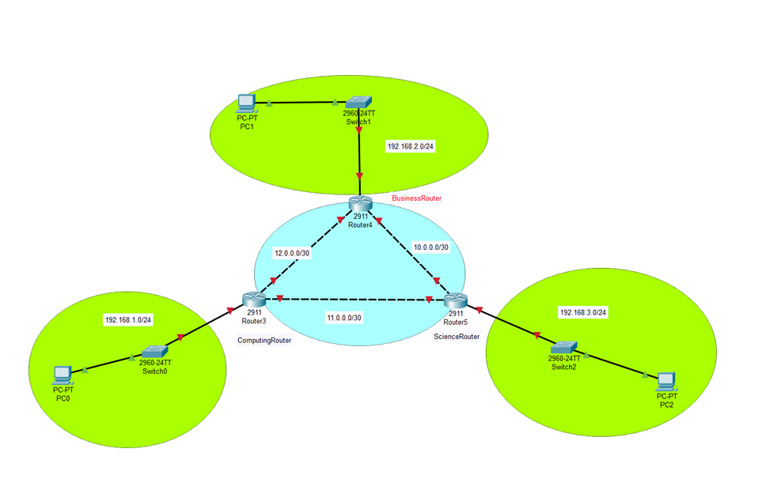

ComputingRouter configuration
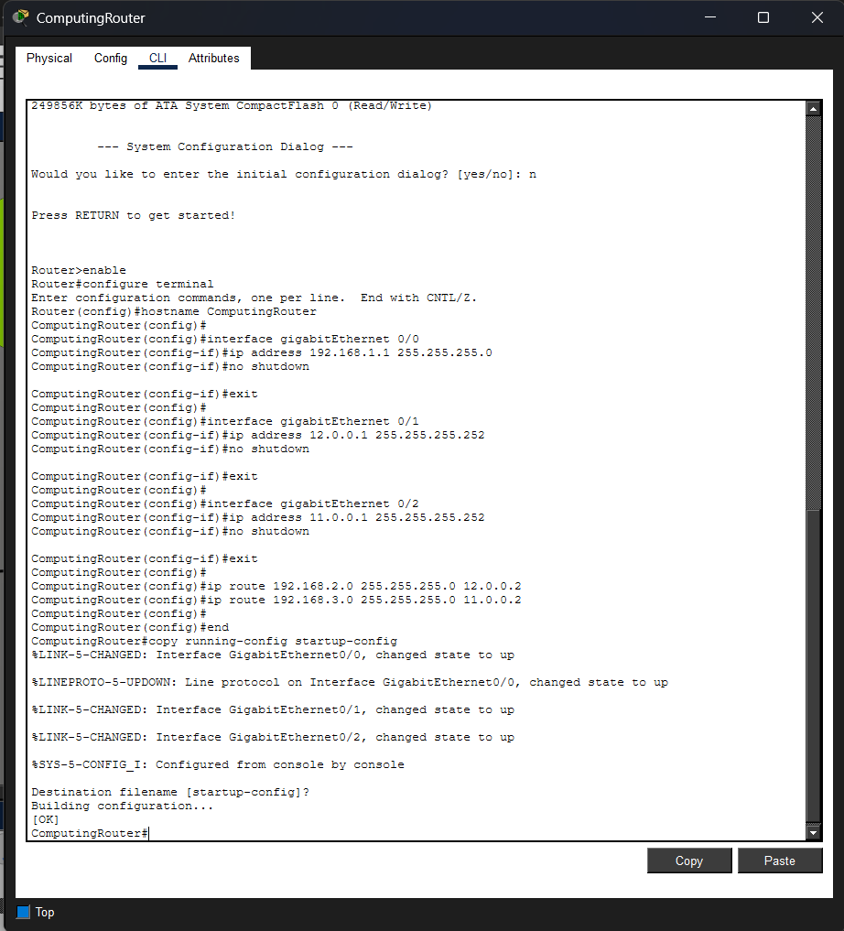

BusinessRouter configuration
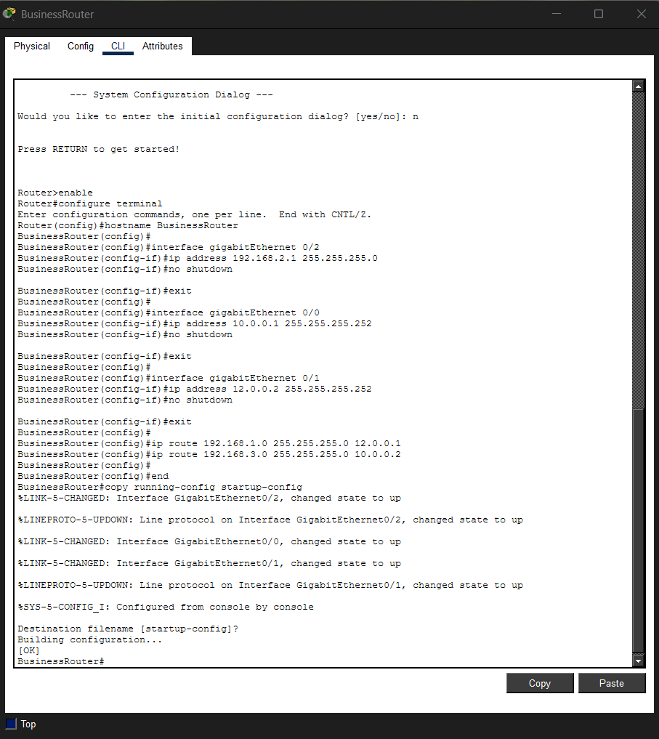

ScienceRouter configuration
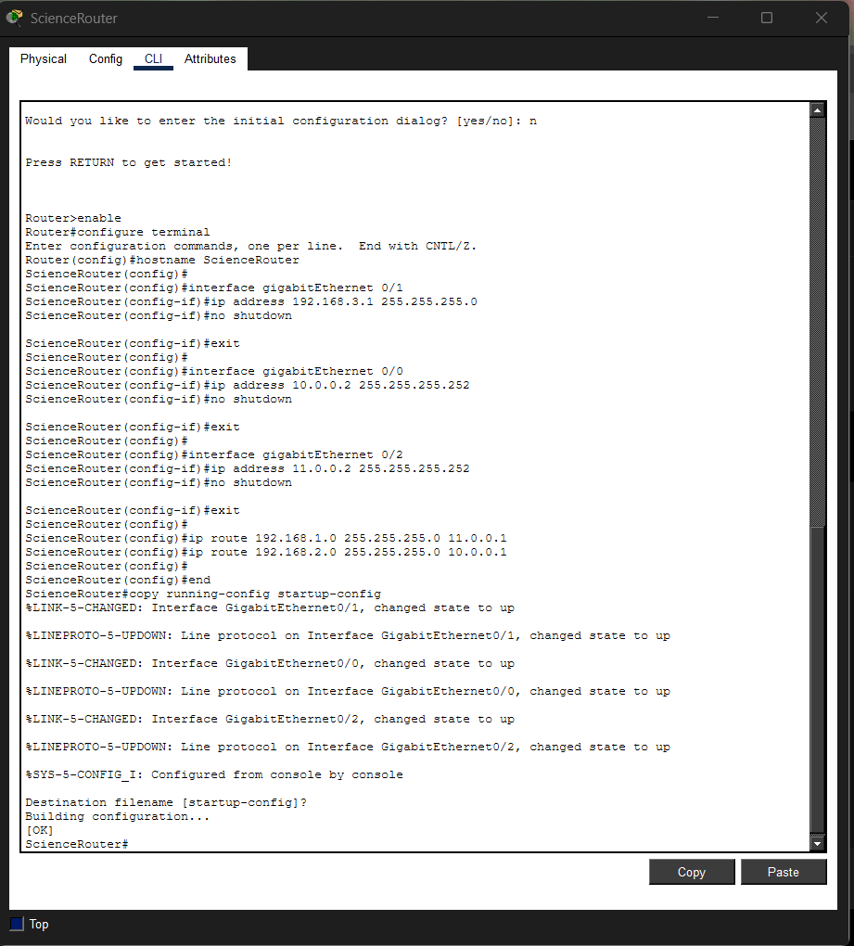

ComputingRouter routing table
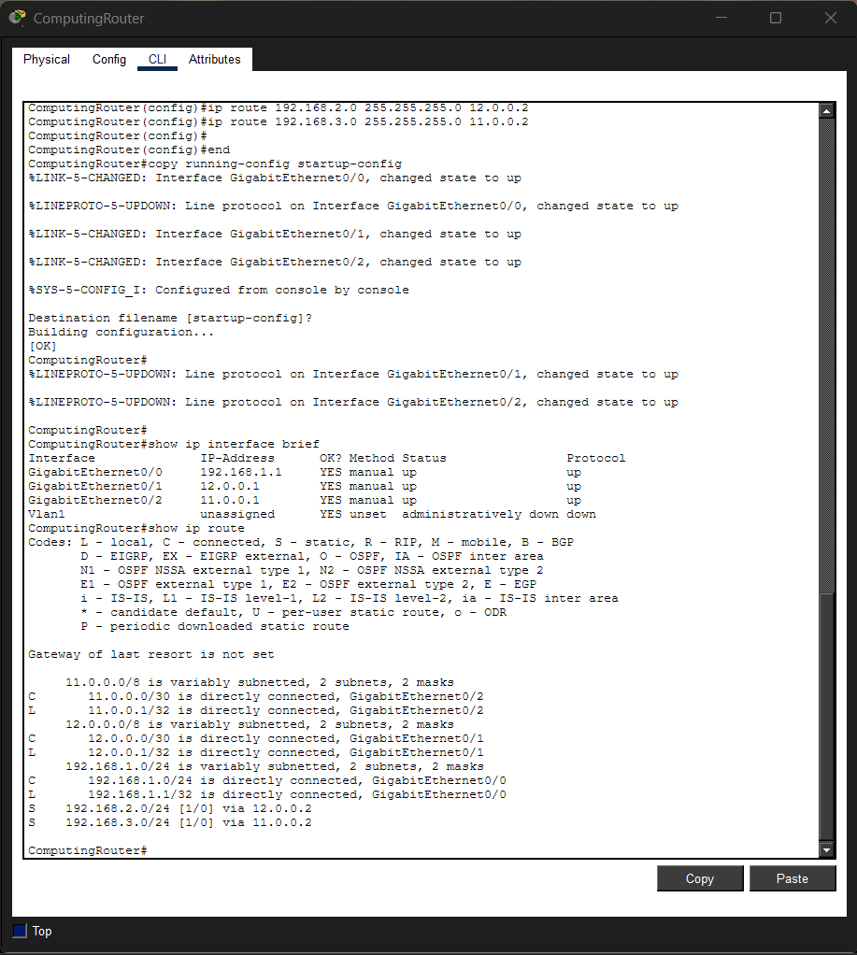

BusinessRouter routing table
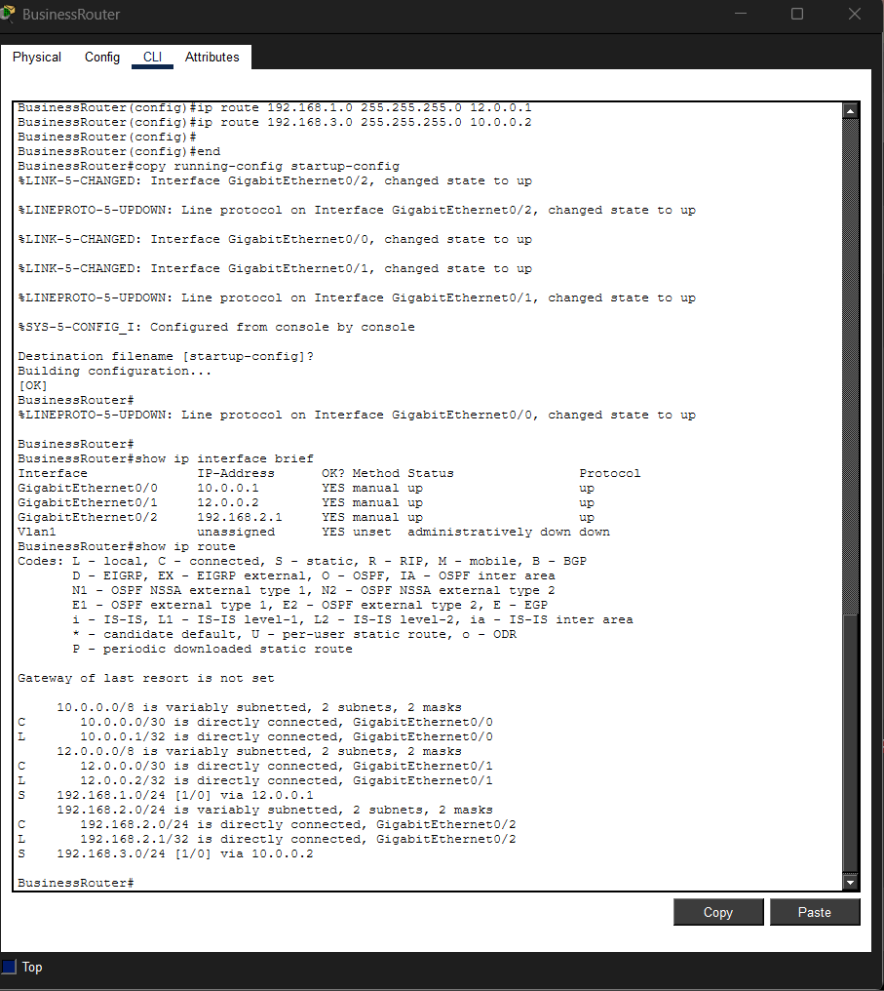

ScienceRouter routing table
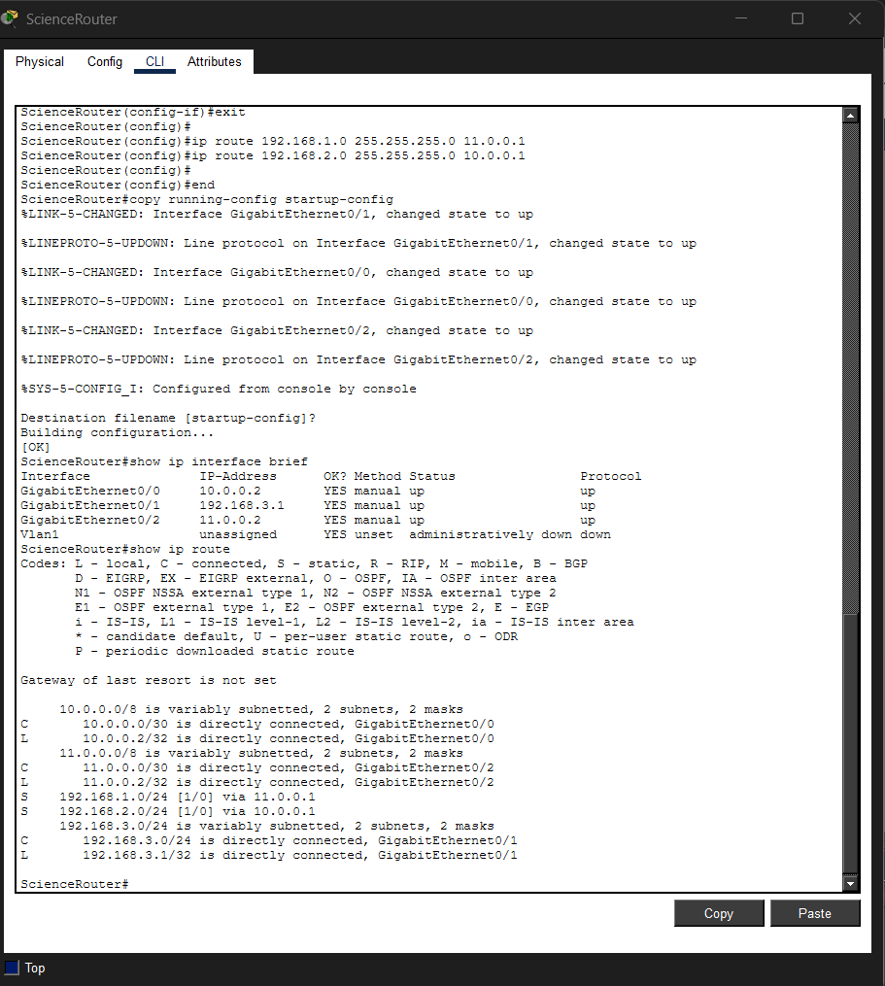

Ping Test Network A ↔ Network B
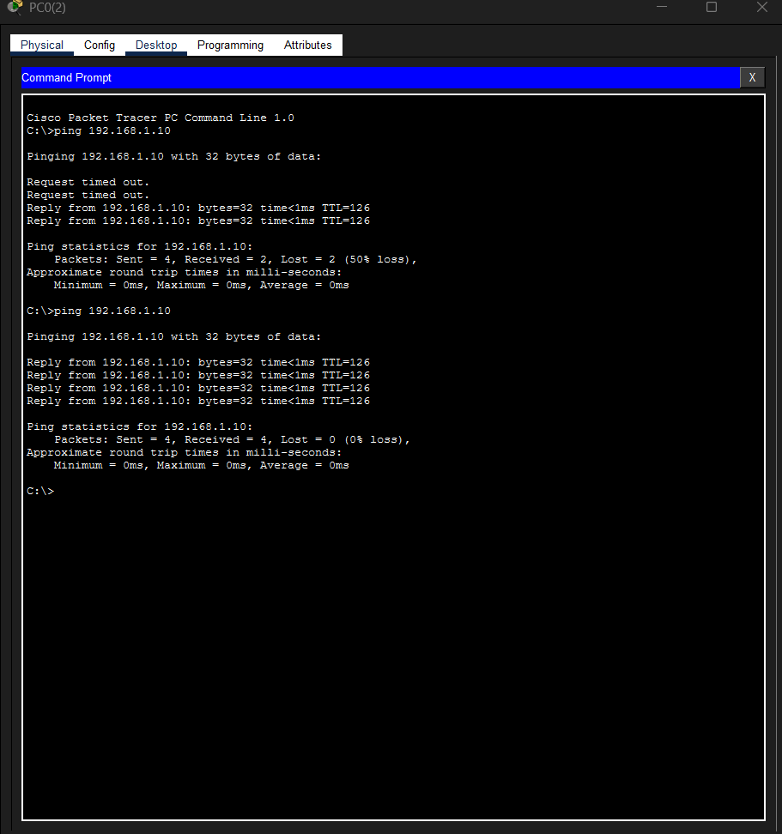

Ping Test Network A ↔ Network C
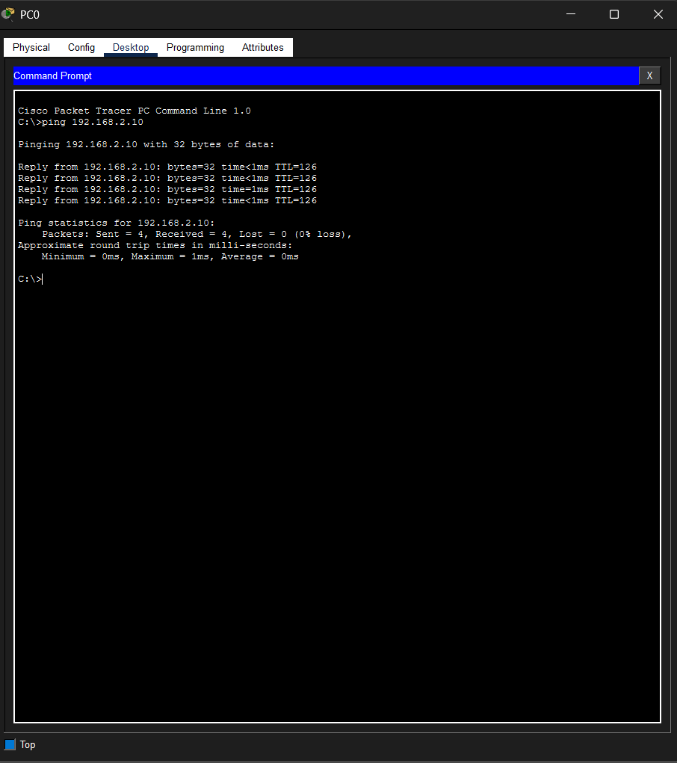

Ping Test Network B ↔ Network C
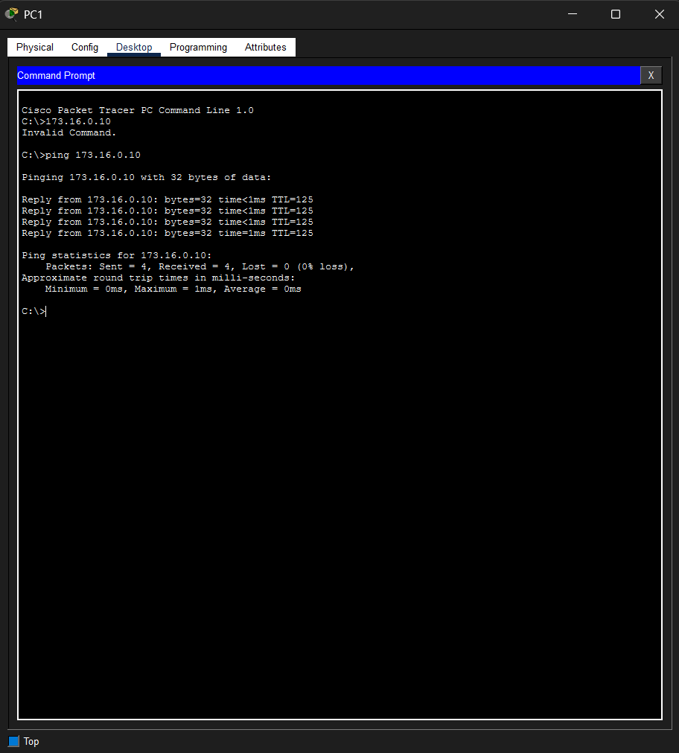

Results
All routers successfully exchanged packets using static routes. Ping tests confirmed successful communication between all networks.

Task 3 – Dynamic Routing Configuration

Part A – RIP Routing

Objective
Configure Routing Information Protocol (RIP Version 2) to automatically exchange routing information among routers.

RIP Configuration

KandyNSBM Router
router rip
version 2
no auto-summary
network 14.0.0.0
network 172.16.0.0

ColomboNSBM Router
router rip
version 2
no auto-summary
network 14.0.0.0
network 15.0.0.0

GalleNSBM Router
router rip
version 2
no auto-summary
network 15.0.0.0
network 173.16.0.0

Explanation
RIP is a distance-vector routing protocol that exchanges routing information periodically. Version 2 supports subnet masks and classless routing.

RIP Network Diagram
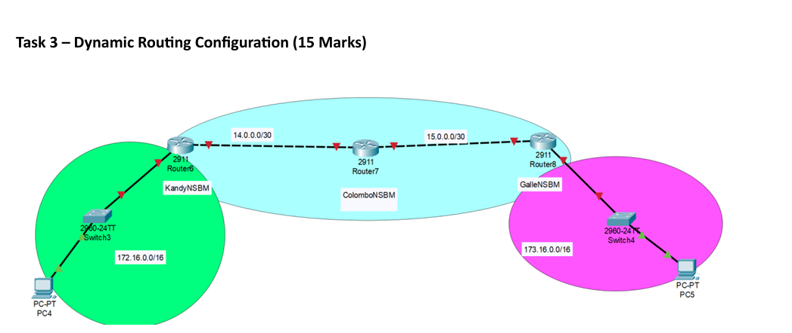

KandyNSBM RIP Configuration
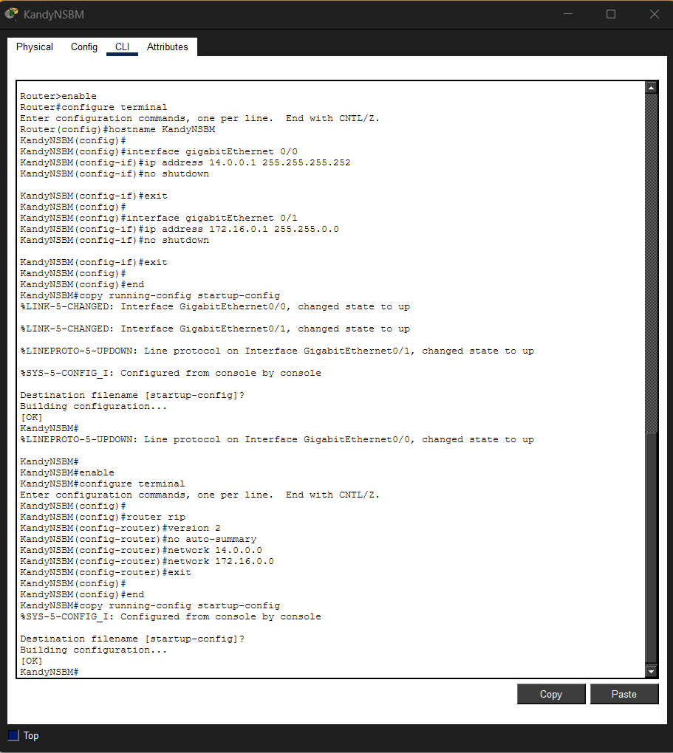

ColomboNSBM RIP Configuration
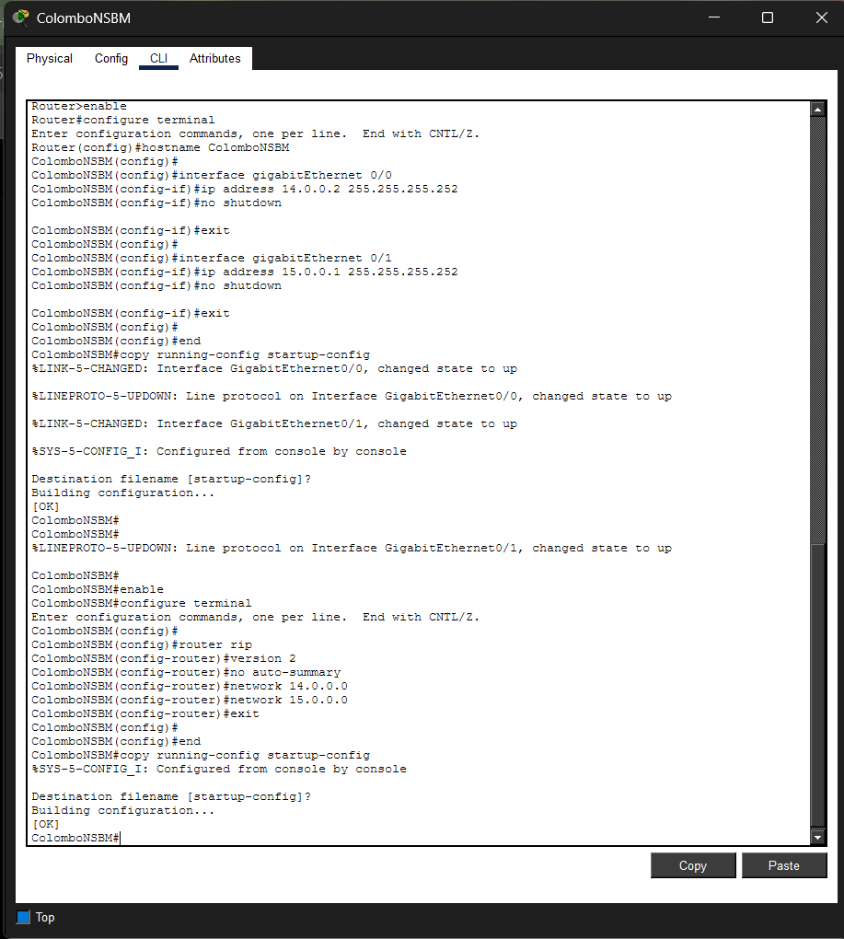

GalleNSBM RIP Configuration
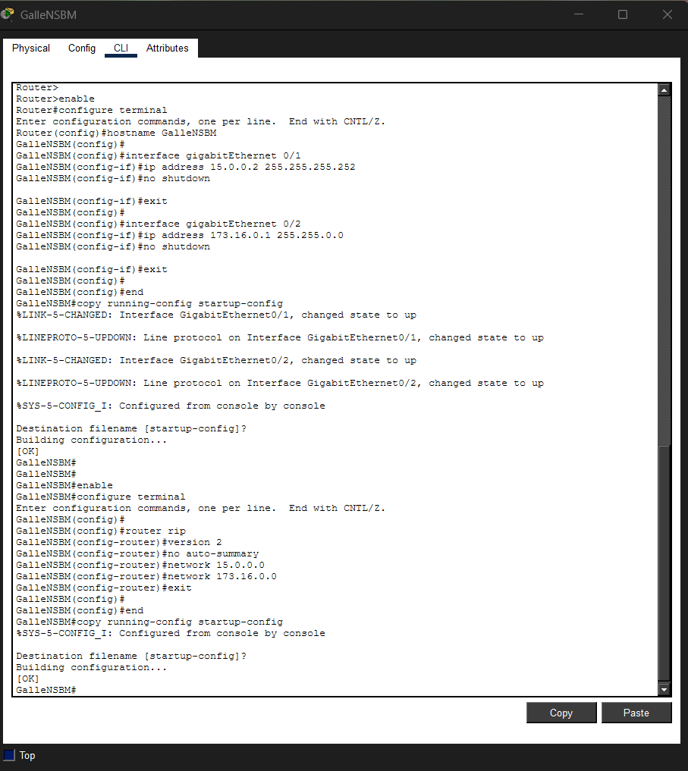

Successful Ping Test
- 

Result
RIP successfully learned remote routes and enabled communication between all networks.

Part B – EIGRP Routing

Objective
Replace RIP with EIGRP and verify network connectivity.

KandyNSBM Router
no router rip
router eigrp 100
no auto-summary
network 14.0.0.0 0.0.0.3
network 172.16.0.0 0.0.255.255

ColomboNSBM Router
no router rip
router eigrp 100
no auto-summary
network 14.0.0.0 0.0.0.3
network 15.0.0.0 0.0.0.3

GalleNSBM Router
no router rip
router eigrp 100
no auto-summary
network 15.0.0.0 0.0.0.3
network 173.16.0.0 0.0.255.255

Explanation
EIGRP is an advanced distance-vector routing protocol developed by Cisco. It converges faster than RIP and uses metrics based on bandwidth and delay to determine optimal routes.

KandyNSBM EIGRP Configuration
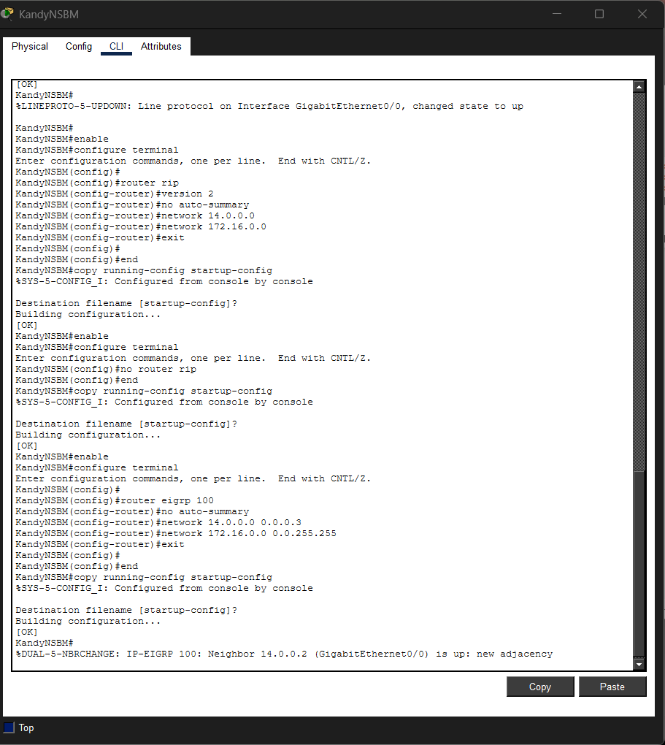

ColomboNSBM EIGRP Configuration
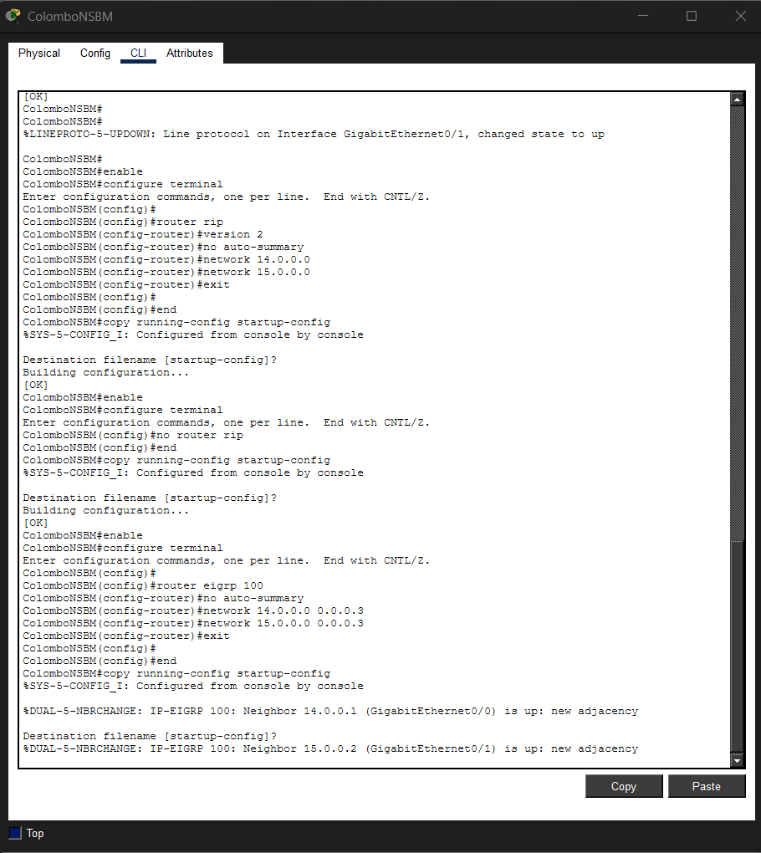

GalleNSBM EIGRP Configuration
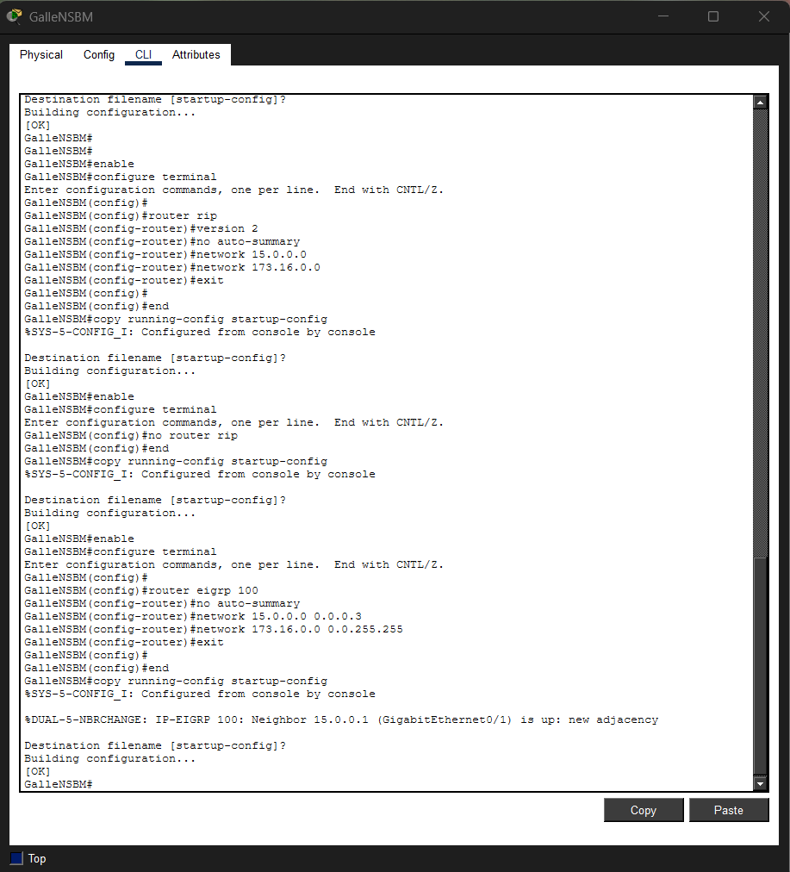

KandyNSBM Routing Table
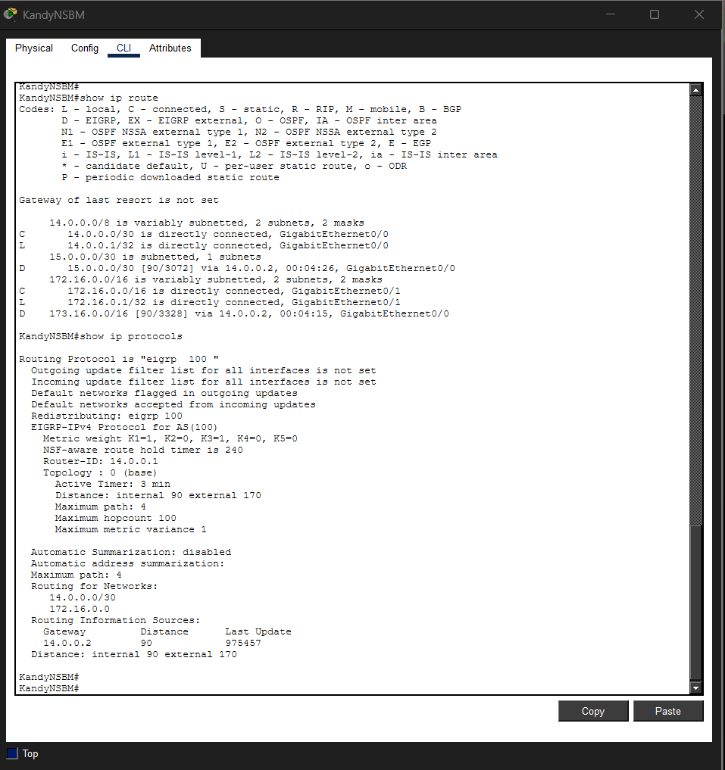

KandyNSBM EIGRP Neighbors
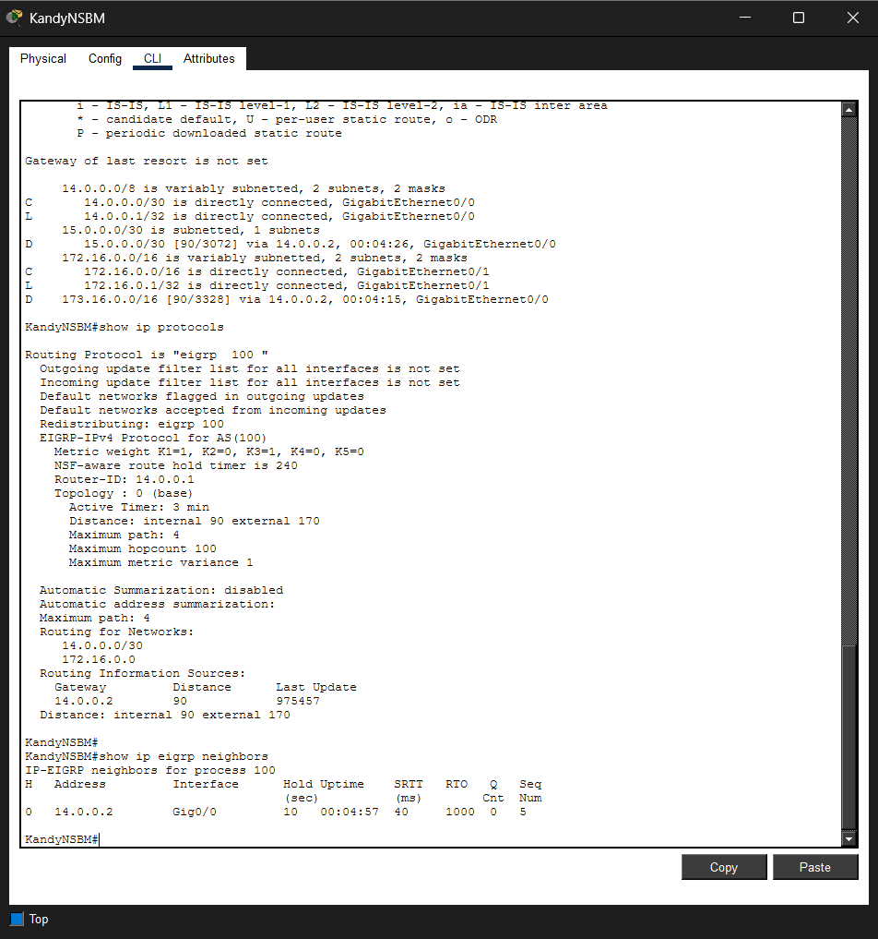

ColomboNSBM Routing Table
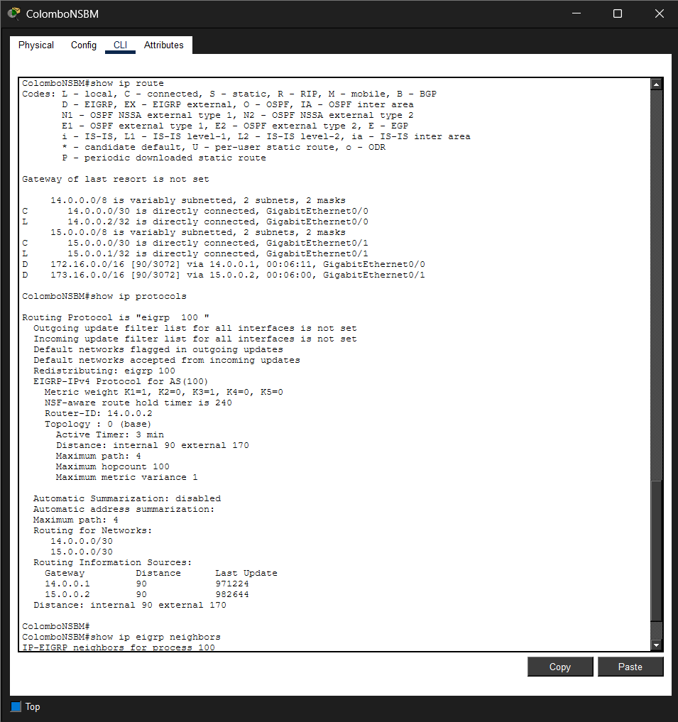

ColomboNSBM EIGRP Neighbors
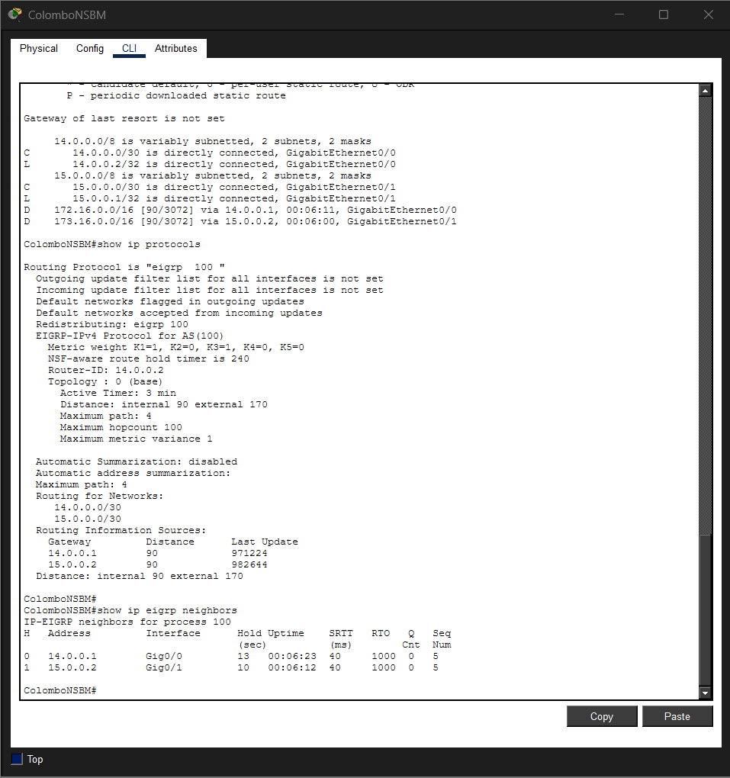

GalleNSBM Routing Table
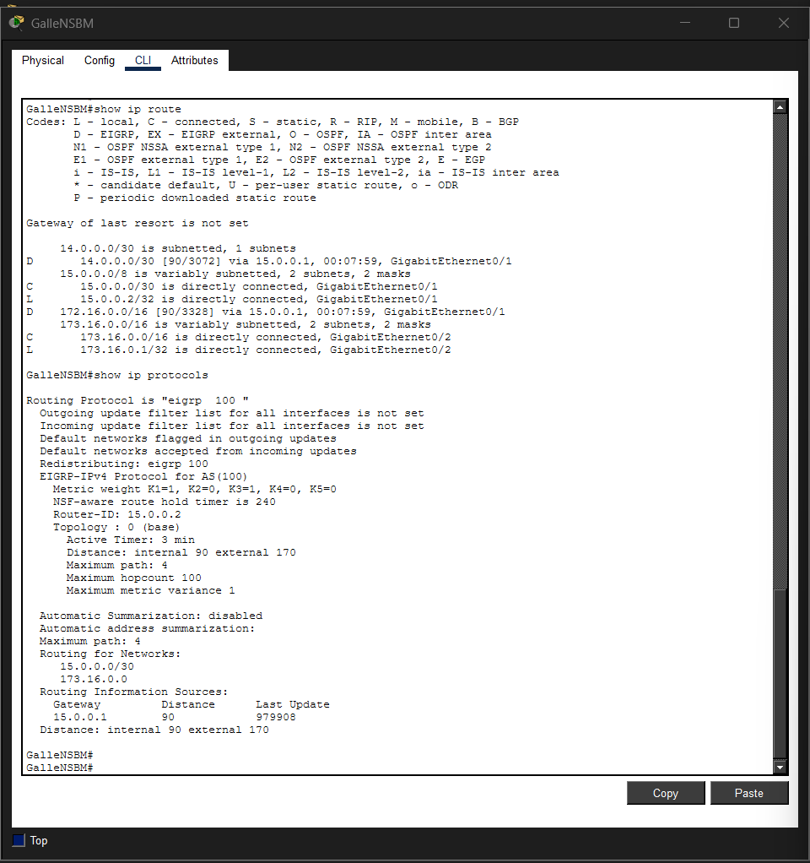

GalleNSBM EIGRP Neighbors
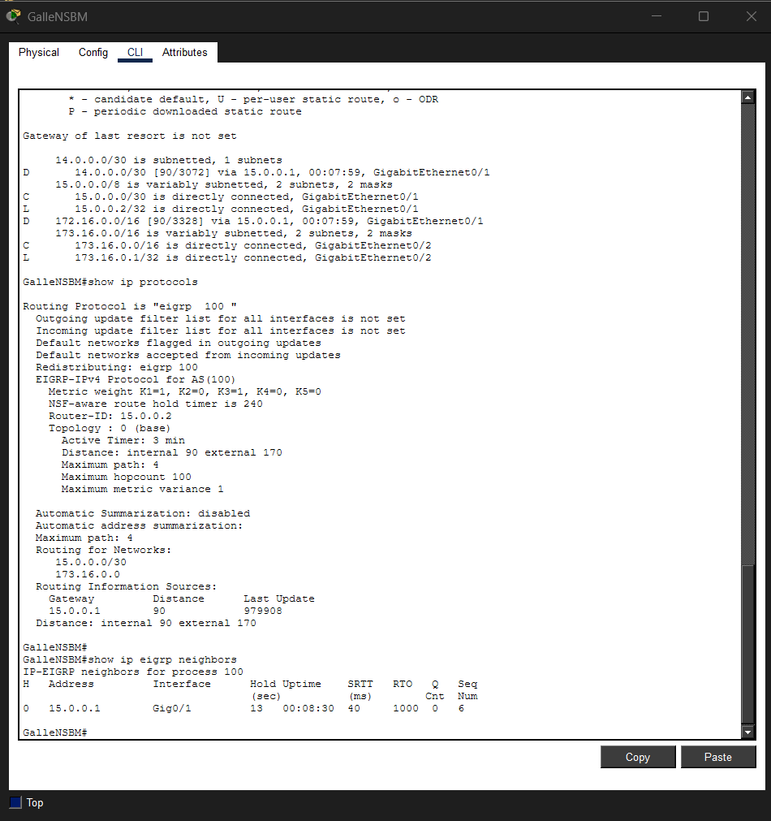

Successful Ping Test
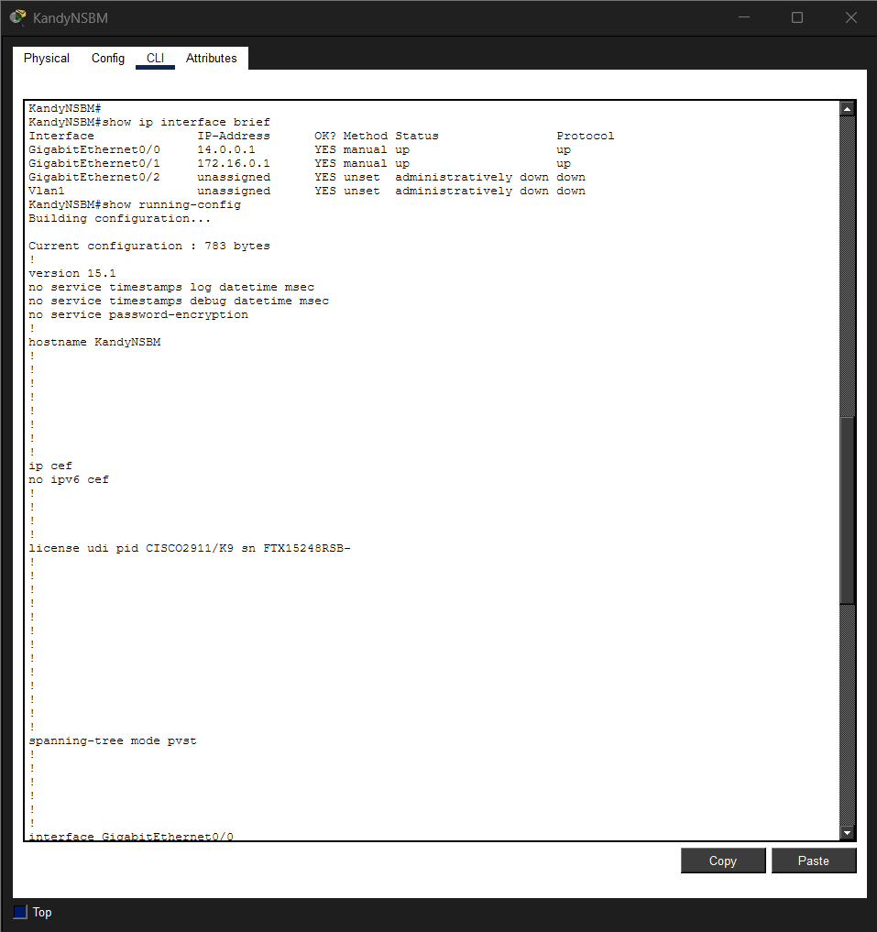

Result
EIGRP established neighbor relationships successfully and dynamically exchanged routes among all routers. Connectivity tests confirmed successful communication between all networks.

Conclusion
This practical assignment provided hands-on experience with Cisco router configuration and routing technologies. Basic router security was implemented through hostname configuration and console authentication. Static routing was configured manually to establish communication among three separate networks. Dynamic routing was then implemented using RIP and EIGRP protocols. Connectivity was verified through routing tables and successful ping tests. The assignment demonstrated the differences between static and dynamic routing and highlighted the efficiency of EIGRP in large-scale network environments.

GitHub Repository
Repository Name: CNRoutingAssignment
Repository Contents:
- Task 1 Packet Tracer File
- Task 2 Packet Tracer File
- Task 3 Packet Tracer File
- README.md Description
- Assignment Report PDF
GitHub Link: https://github.com/mandfernando/CNRoutingAssignment

